**Task Manager API**

Instructions to be Followed While handling this API:-

* First off all you have download postman App.
* Set the production Environment to your postman App By clicking on setting icon given at the right corner.

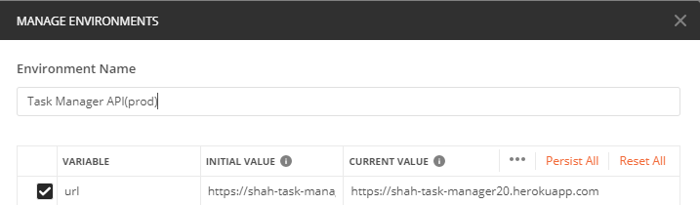

* Put production link i.e ([https://shah-task-manager20.herokuapp.com](https://shah-task-manager20.herokuapp.com/)) to both initial and Current value.
* Then After follow the Steps given below :-

**Step: 1**

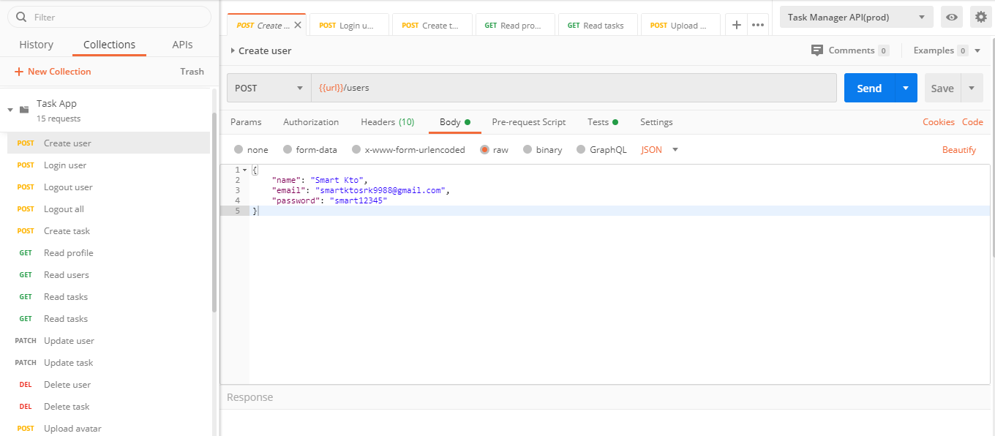

**Step: 2**

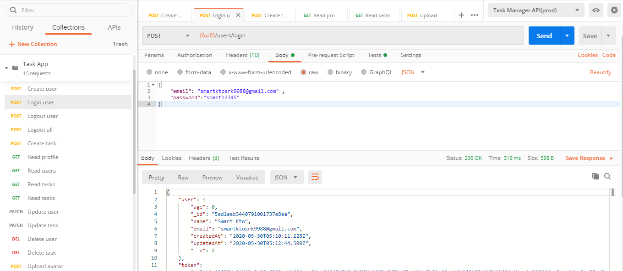

**Step: 3**

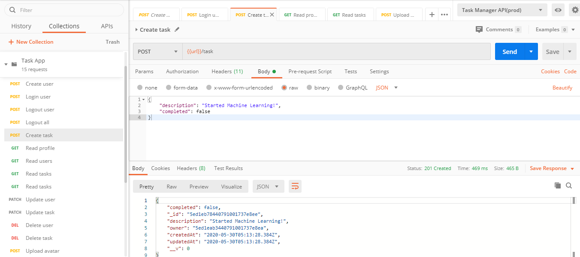

**Step: 4**

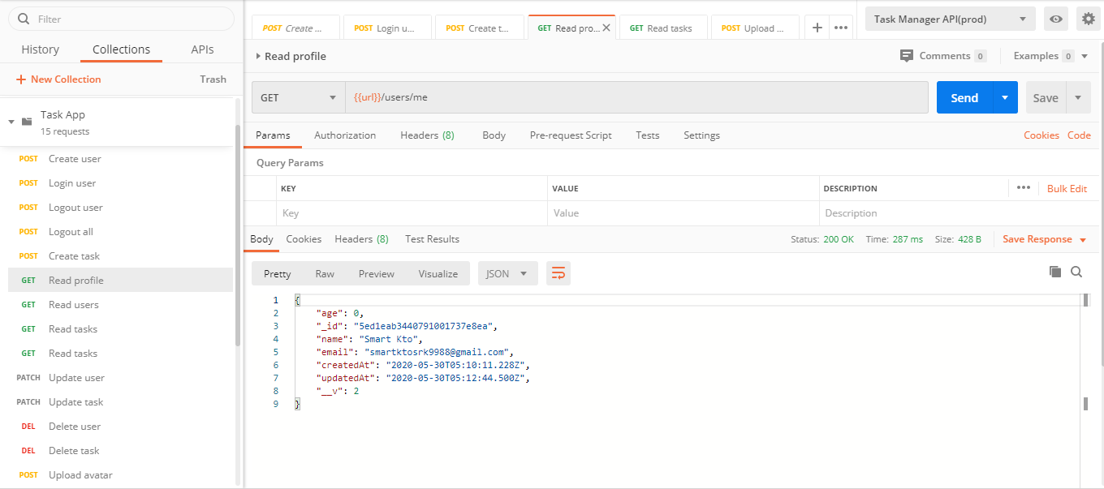

**Step: 5**

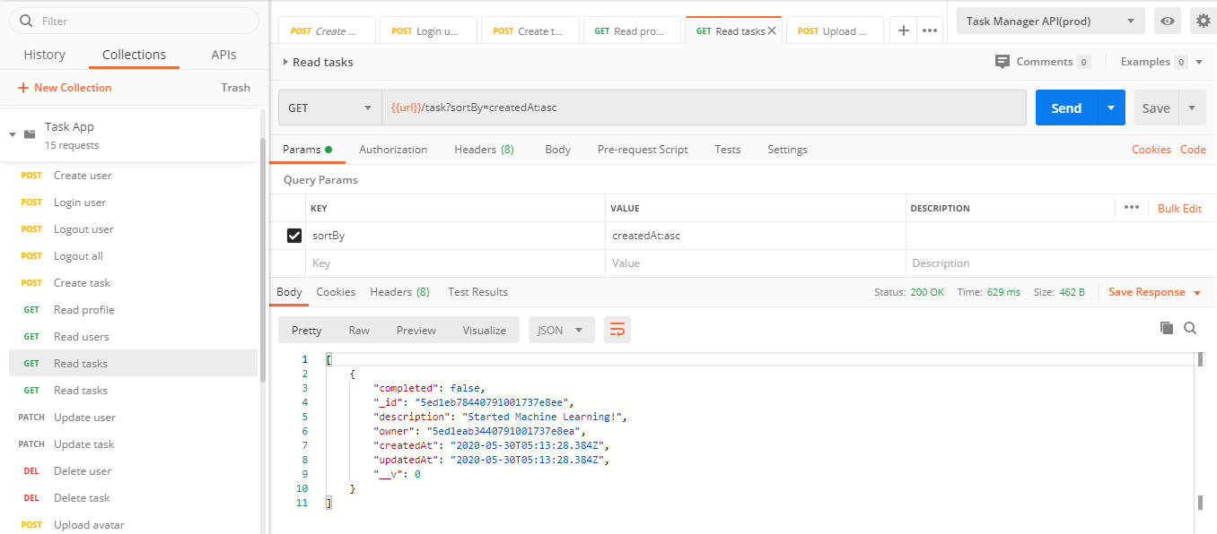

**Step: 6**

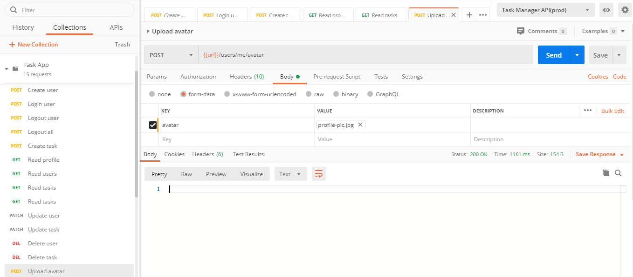

**Step: 7**

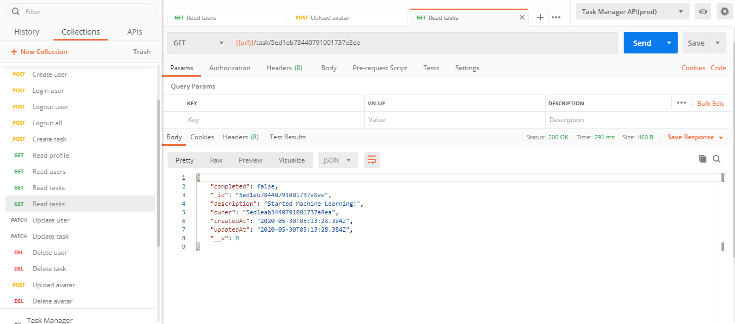

**Step: 8**

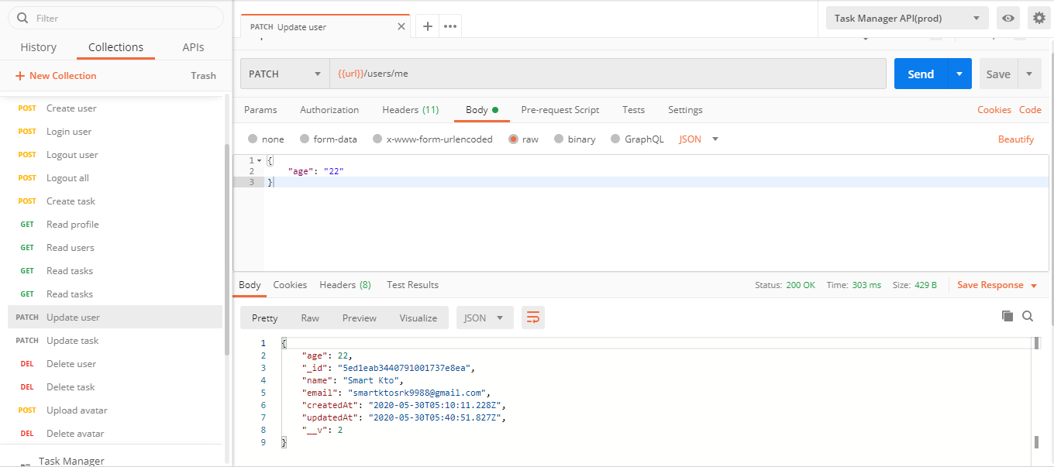

**Step: 9**

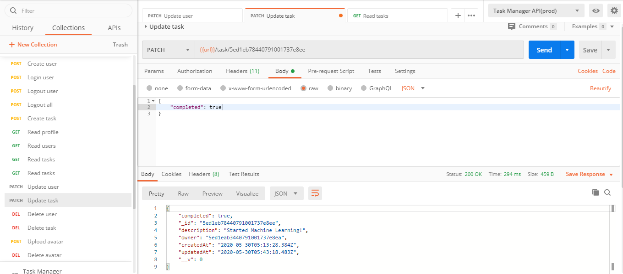

**Step: 10**

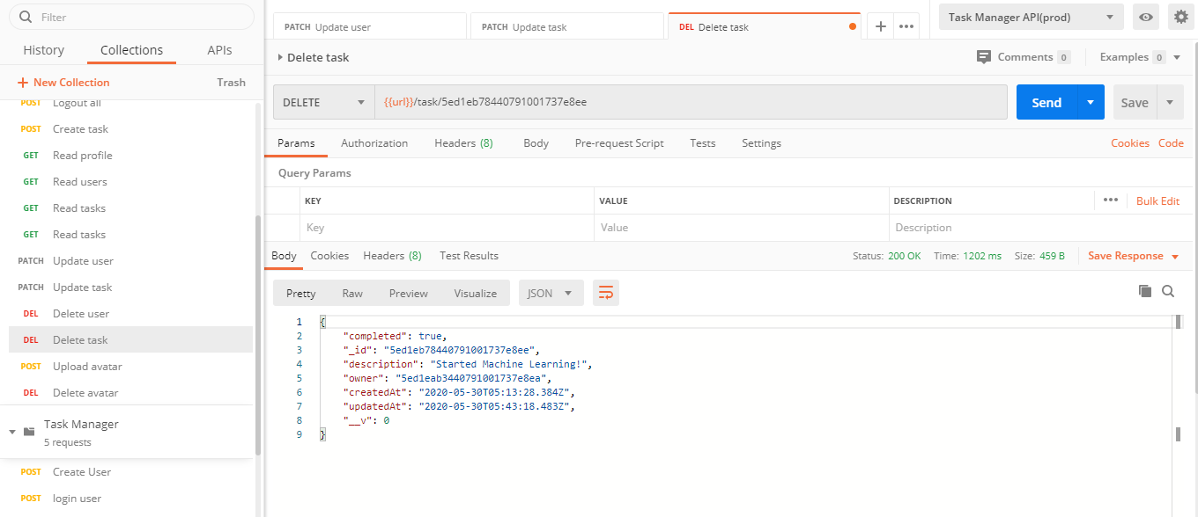

**Step: 11**

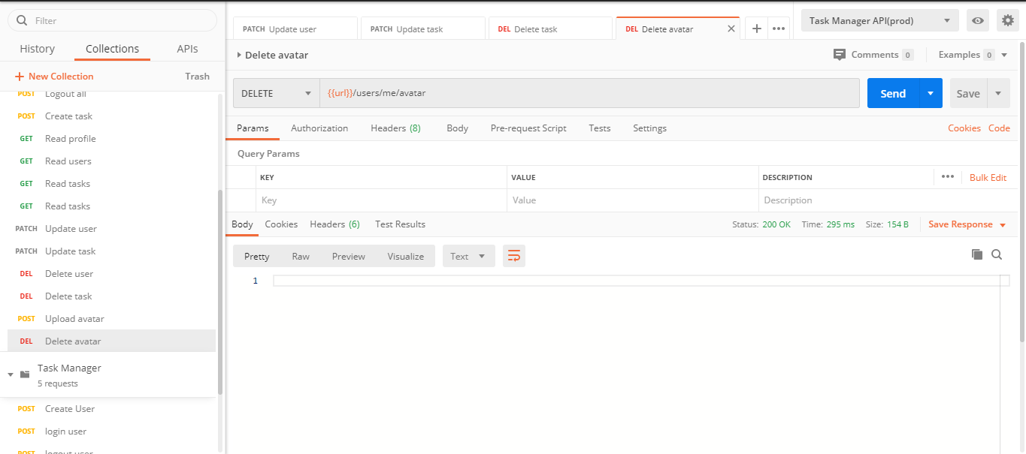

**Step: 12**

